

Drag Ragdoll Rigidbody

+ Fly Camera
Simple script for your ragdoll flying needs.
Try it out in the “RagdollTestScene.unity” scene.

Drag Ragdoll Rigidbody
This is a simple script to drag around ragdolls (or any object with Rigidbody) with the mouse. It is useful for testing out the limits of your ragdoll setup. It works by temporarily attaching invisible spring joint to the clicked rigidbody and moving it with the mouse. Springs can be seen in the screenshot below - the green lines pulling the character legs.
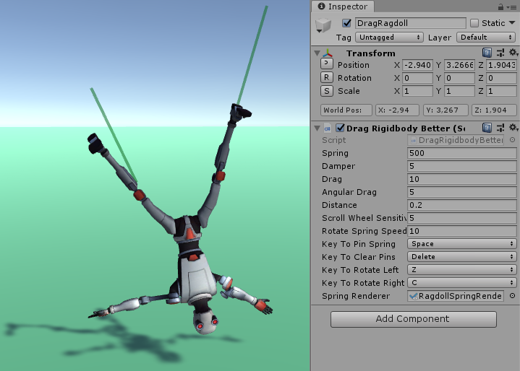
This script is a replacement for the now removed DragRigidbody that was packed with the Unity Standard Assets.
It adds some neat features and controls like twisting, pin the springs and render the springs.

Usage
Attach the DragRigidbodyBetter script to an empty object in the scene. It will spawn dragged springs as child objects.
Set prefab with LineRenderer component to the “Spring Renderer” field to visualize the spring.

Controls
- Left mouse button on any rigidbody - drag it.
- While dragging:
  - - Scroll wheel - drag object closer or further
  - - Space - pin active spring at current mouse position
  - - Delete - destroy all pinned springs
  - - Z/C - twist active spring to left or right

Troubleshooting
If dragging rigidbodies doesn’t work, make sure the following conditions are met:
- Rigidbodies must have “Is Kinematic” turned off.
- Rigidbodies shouldn’t weigh too much. If they do, increase the drag force via the “Spring” value of script.
- Every rigidbody must have child colliders – colliders outside rigidbodies can’t be dragged.
- No other component is controlling the rigidbodies or colliders (for example Animator).

Fly Camera
Allows the game camera to be controlled like the editor Scene View camera (using right-click-drag + WASD). Just slap the FlyCamera script on your camera and it will start working.
Very useful for game jams or prototyping.

Controls
- WASD to move
- Q / E are up / down
- Hold Shift to speed up
- Pan with the middle mouse button
- Rotate with the right mouse button
- Scroll wheel - zoom
Links
GitHub | Assets Store

